# Steps to enable Java in web browser

## **Platform(s):** Windows 7, Windows 8

## **Browser(s):** IE 9, IE 10, IE 11 and Firefox 41

Applets do not run because Java is not enabled.

Please do the following configurations in your machine’s to let IE 9+ to allow Java Applets for DSC Selection.

### Follow these instructions to enable Java though your Web browser.

1. Install Java 32 bit JDK 1.7/1.8 on your system.

Note : Please make sure that only one 32 bit java version is installed in your system.

If multiple java versions are installed please uninstall all of them and install the latest.

1. Open Java Console: Start -> Type Configure Java -> Click on Configure Java.

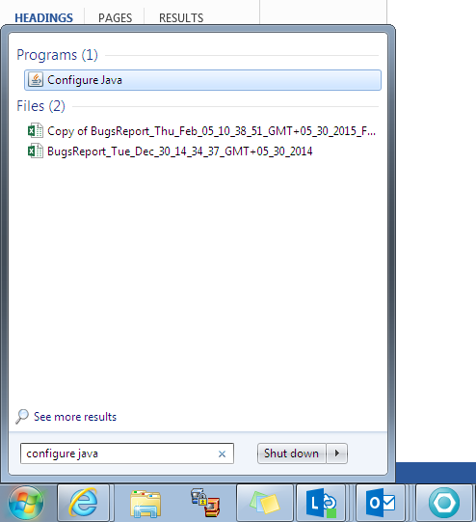

1. In the Java Control Panel, click the **Security** tab.
2. Select the option **Enable Java content in the browser**.
3. Click Edit Site List and add DEV,SIT and UAT URLs .
4. Click Apply and then OK to confirm the changes.

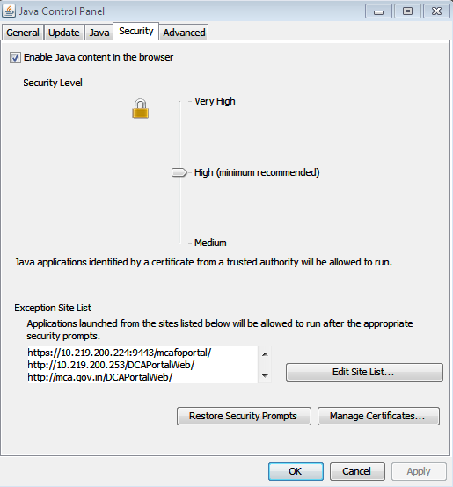

1. Click **Advanced Tab**
2. Perform certificate revocation checks on -> choose Do not check (not recommended)
3. Click Ok to confirm the changes.

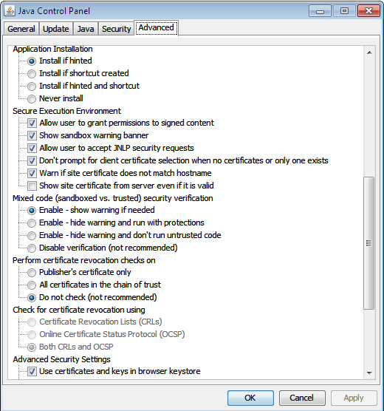

1. Restart your browser (close all browser windows and re-open), in order for the browser to recognize the changes.
2. Install a valid DSC on your machine and see if it appears in the Login page when you try to login with DSC.

Note : Try below instructions if above changes does not show applet in IE.

**Internet Explorer**

1. Click **Tools** and then **Internet Options**
2. Select the **Security** tab, and select the **Custom Level** button
3. Scroll down to **Scripting of Java applets**
4. Make sure the **Enable** radio button is checked
5. Click **OK** to save your preference

