ORGANISATIONAL CHART OF THE MINISTRY OF CORPORATE AFFAIRS

Last Updated: July 2014
MINISTER OF CORPORATE AFFAIRS

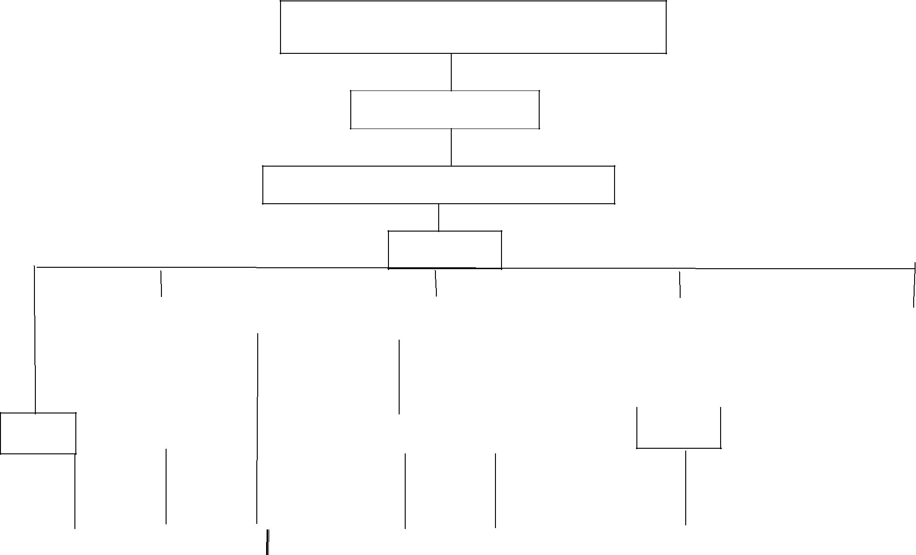

MINISTER OF STATE

SECRETARY

ADDITONAL SECRETARY

JS(SP)

 | DIR (NC) |  |  |  |  |  |  | DS(JSA)
 | Dir(NC |  |  |  |  |  |  |  |  |  |  |  |  | DS(BPP) |  |  |  |  | JD(OL)
US(KK) |  | US(KK) |  |  |  |  | US (AHA) |  |  | US(AP) |  | US(AHA)
Hindi
 |  |  | Ad.I |  | Genl |  |  |  |  |  | IICA |  | Bud |  | Hindi
Library |  |  | Ad.I |  | Genl |  |  |  | Coord |  | IICA |  | Bud |  | Hindi
 |  |  | Ad.I |  | . |  | Parl |  | Coord |  | IICA

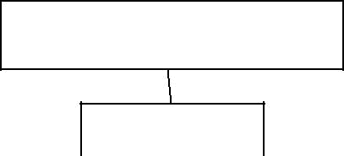

SECRETARY

JS(B)

DII(RC) |  |  | JD |  |  | JD(VS) |  |  | US(RKP)

DD(NKD)

 |  |  |  |  | LEGAL
CL-I |  |  | CL.V |  | LEGAL
 |  |  | (POLICY)

DII(UCN)

JD(LRM)

JD(BKL)

DD(RKB)/DD(SS)

DD(SY)

AD(PS)/(IHA)/

(HS)/(AM)
SECRETARY
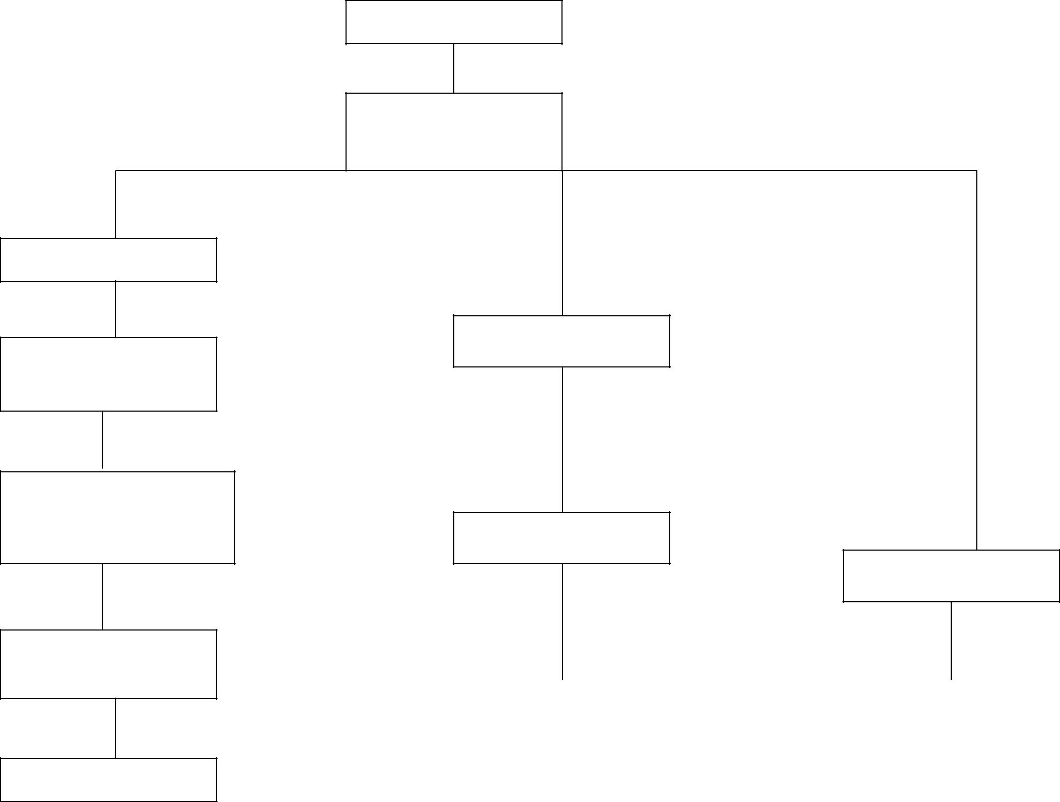

ADDITIONAL

SECRETARY

DS(BPP)

US(RV)

US(RK)

Vig |  | ADM.III

CL.II

AS & FA

Dir(PS)

CCA

DS(SK)

DS(BPP)

US(AK)

US(AHA)

 | US(AHA) |  |  |  | IFD |  | Statistics
SECRETARY
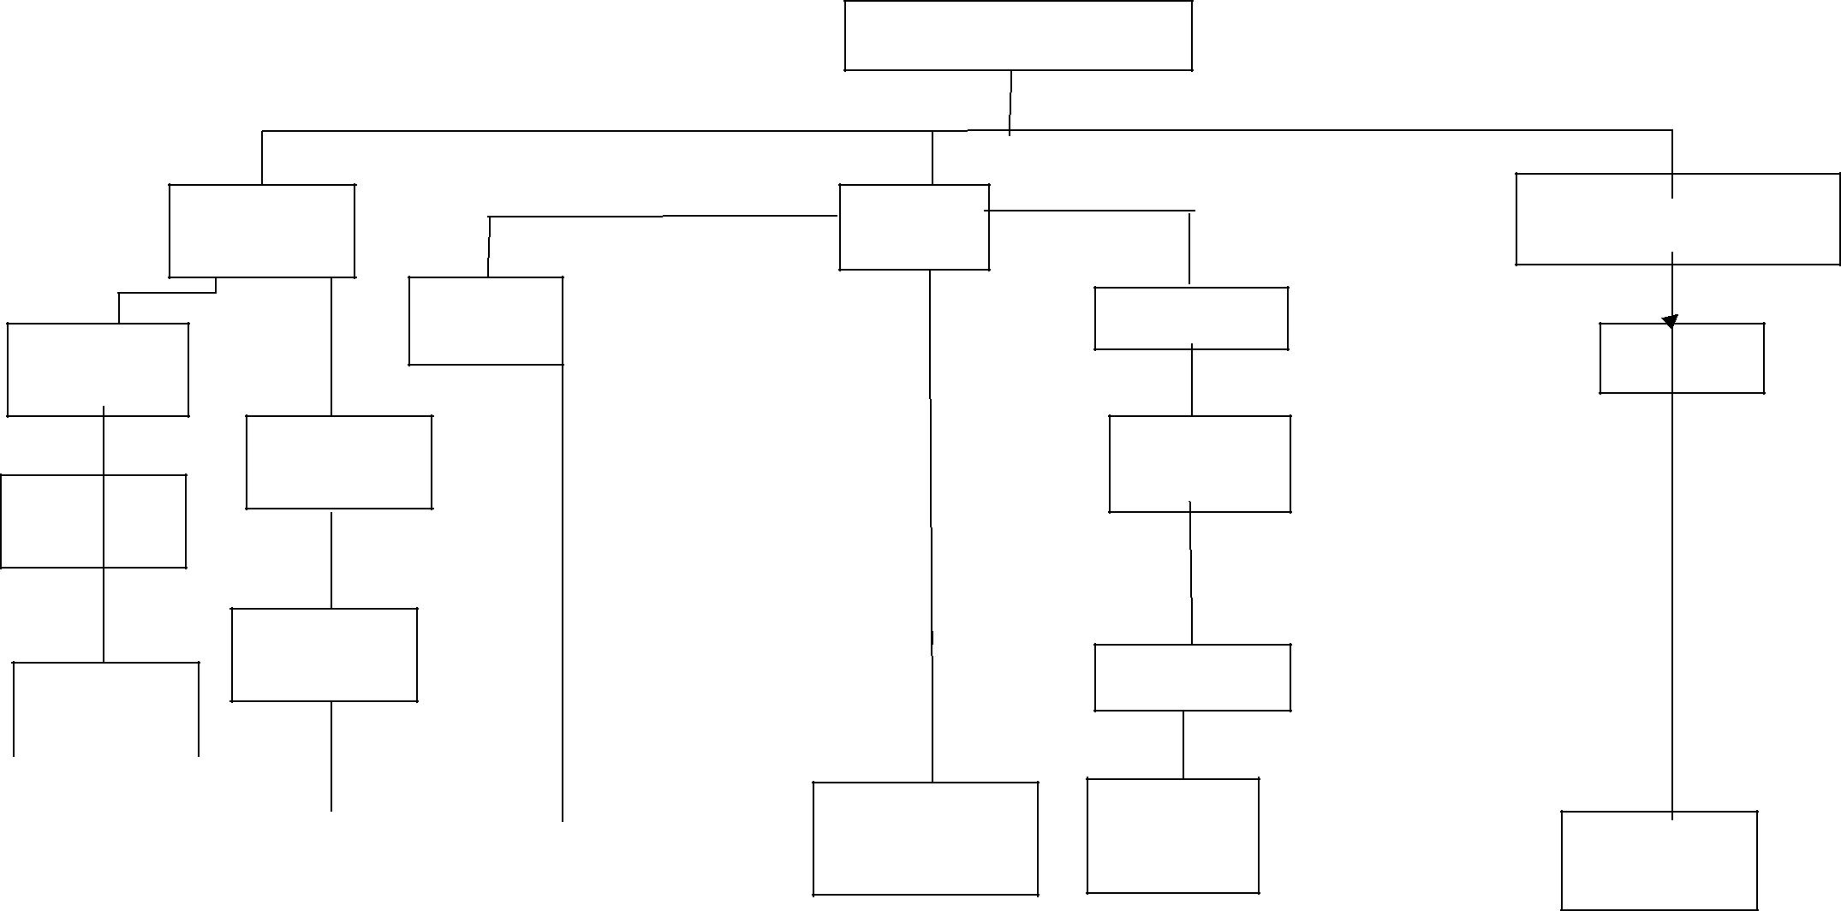

EA |  | Adv.(Cost)(BBG)
 | Dir(R&A)
 |  | DIR(VK)
 | JD(KLK )
 | DD(EN)
FIPB & Eco | R&A
Matters | Division | Cost Audit
 |  | Branch

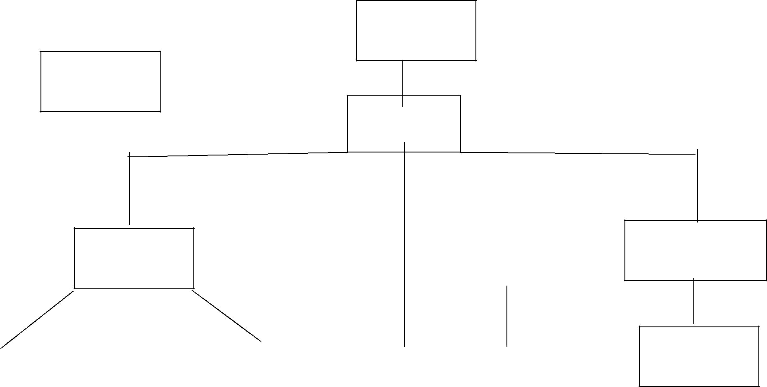
ADDITIONAL
SECRETARY

DIR(NC)

JS(B)

DIR(AK)

 | US(BPB) |  |  |  |  |  | US(RK)
 |  |  |  |  |  |  |  |  |  | US(RKP)
 |  |  |  |  | ADM.II |  |  |  |  |  | IGM
IEPF |  |  | ADM.IV

DIR(AB)

US(GPS) DD(SS)

DD(SG)/
DD(MSP)

COMPUTORIZATION
E-

GOVERNANCE
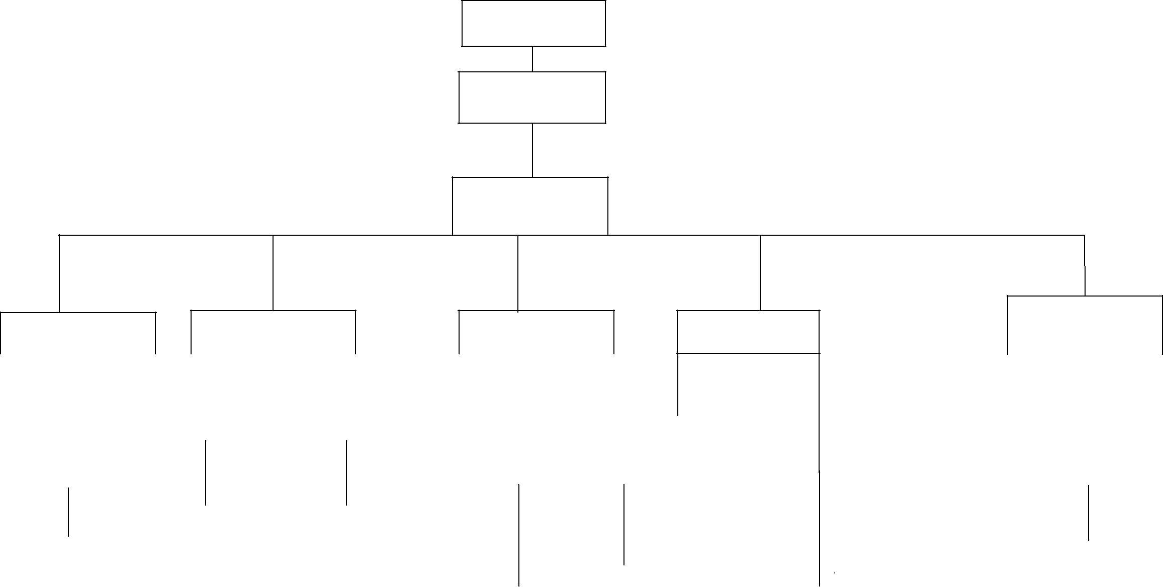
SECRTARY

ADDITIONAL

SECRTARY

JS(M)

DS(RJ)
DS(SK) | DIR(AB) | DS(BM) | DS(JSA)

 |  |  |  |  |  |  |  |  |  | US(AHA) |  |  |  | US(AP) |  |  |  |  | US(AP)
US(RV) |  |  |  |  |  |  |  |  |  |  |  |  |  | US(AP) |  | US(LKT)
 |  |  |  |  | US(JBK) |  |  |  |  |  |  |  |  |  |  | US(LKT)

 | AD(PD)
 |  |  |  |  |  |  |  |  |  |  |  |  |  | IICA
 |  |  |  |  |  |  |  |  |  | INFRA
 |  |  |  |  |  |  |  | PI |  | INFRA |  | CL.VI &
 |  |  |  |  | Compt. |  |  | PI |  |  |  | CL.VI &
 |  |  |  |  |  |  |  |  |  |  |  | CL.VII
 | Insolvency &
 | CL.III

